Minimal Example User Guide

This guide explains how to import biological parameters, configure program settings and load map files,
so that you can successfully run the demo case.

Run **ui_selector.py**, and the following window will appear.
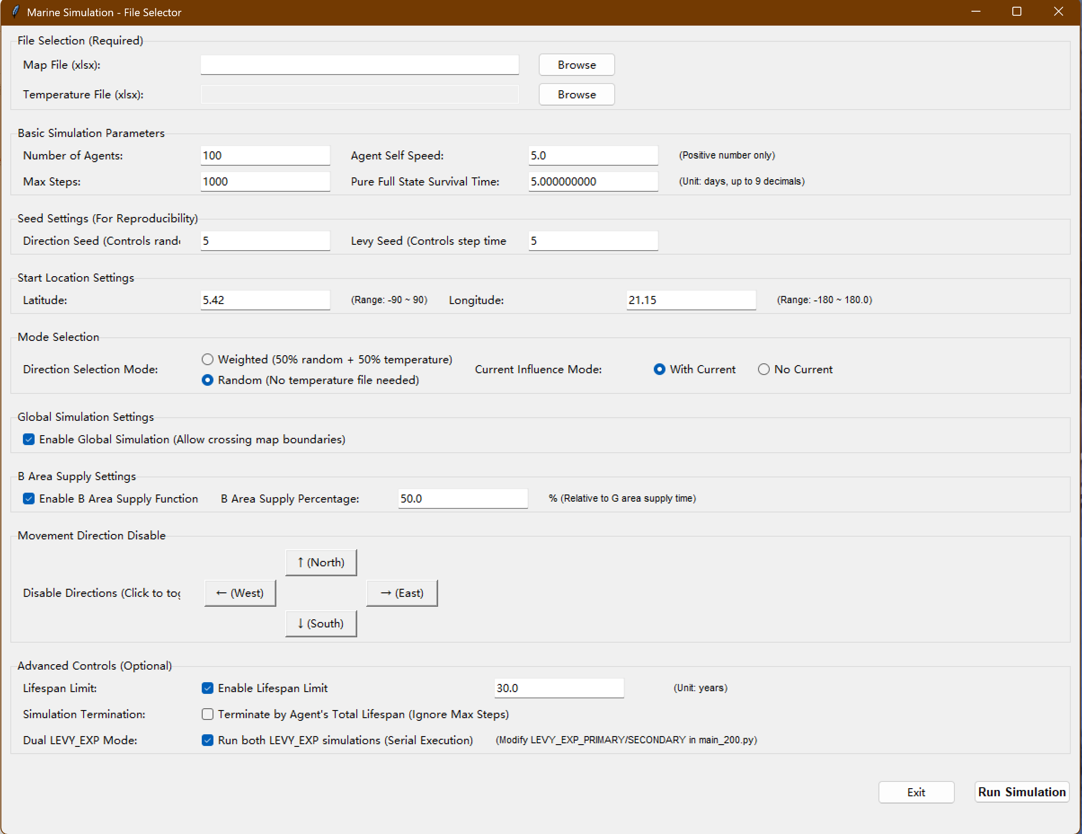
The Mesozoic matrix map file is an XLSX file with a dimension of 360 × 180 (rows × columns), which can be obtained from the prepared folder **map for simulation**. For this example, select and import **245.xlsx** in the **map file** field.
The temperature file corresponds to the environmental temperature map. Since detailed environmental temperature data for the Mesozoic is unavailable, you may leave this field unselected by default. In this case, simulated individuals will not navigate based on temperature.

Next, navigate to the **basic simulation parameter** section. Here you can set the total number of simulated organisms (**number of agents**) and the maximum movement steps (**max steps**). Both values can be adjusted according to your experimental scale. It is recommended to set **number of agents** to no less than 10 and **max steps** to no less than 1000.

You may also configure the cruising speed of individuals (**agent self speed (m/s)**) and their maximum survival duration (**pure full state survival time (day)**). If you have relevant data for the simulated species, please fill in the values manually.

This example uses *Cartorhynchus lenticarpus*. The corresponding parameters can be found in the file **Experimental Species Information and Simulation Parameters.xlsx**:
- agent self speed = 0.242032984
- pure full state survival time = 2.029244098

The seed setting is optional. After launching the program, a random seed will be automatically generated to determine the random moving directions of simulated individuals and the jump length of each Lévy flight step. If you wish to reproduce previous results, enter the random seed recorded in your exported data here.

Finally, configure the **start location**. You need to enter latitude and longitude values. Taking the fossil locality of *Cartorhynchus lenticarpus* as an example, its coordinates obtained from **Experimental Species Information and Simulation Parameters.xlsx** are **N20.98, E103.27**. Please input **20.98** for latitude and **103.27** for longitude respectively.

For locations marked **S20.98, W103.27**, enter **-20.98** and **-103.27** accordingly.
You have finished importing basic parameters. Now click run simulation to run the model, view and export the results.

